Item Trading Hub
Group 21

Website viewing/setup instructions:
- Download and install AMPPS (https://ampps.com/download)
- Download and unzip the itemtradinghub.zip folder
- Place the itemtradinghub folder in the AMPPS/www directory on your hard drive
- Depending on your OS, do the following:
  - Windows
    - Open the command prompt and type cd C:\”Program Files (x86)\Ampps\mysql\bin” mysql -u root -pmysql
    - Password: mysql
  - Mac
    - Open the terminal window and type /Applications/ampps/mysql/bin/mysql -u root -pmysql
    - Password: mysql
  - Linux
    - Open the shell window and type mysql -u root -p
    - If you have a password, enter it, otherwise hit Return
- Start AMPPS and make sure the Apache and MySQL servers are toggled ON
- Navigate to localhost/itemtradinghub in a web browser to view the website.

Objective

The goal of this project was to create a website where users could interact in order to trade items between one another. The functionality was modeled similarly to Craigslist – including being able to create an account, post items for trade, and view all available items for trade. Upon finding an item that the user is interested in, the user can message the owner of that item to negotiate a trade deal. When posting new items for trade, users can also indicate what kind of item they are looking for in return. In this way, “buyers” and “sellers” (traders and trade-ees) can easily communicate and trade items back and forth that both parties are interested in.


Summary



The Item Trading Hub website is based off a previous assignment referred to as “lamp stack”. This provided a solid starting point for the website that included simple login and logout functionality as well as a messaging system between members. The website is hosted on a local machine using AMPPS, which provides Apache and mySQL server functionality and PHP interpreting. AMPPS allows you to host an Apache/mySQL database on your local machine and access it via the phpMyAdmin interface, as well as host the website’s file structure with your local machine acting as a server to serve the webpages via web browser. This local web hosting allows you to make changes to the website and see how it looks live in a web browser. Normally this is not possible with a PHP-based website, as web browsers cannot directly interpret PHP files, as they must be served via server.

The vast majority of the website’s files are PHP files, with one javascript and one CSS file. Working with PHP allows the site’s webpages to be dynamically built, as well as interact with the database more easily than can be done with plain HTML.



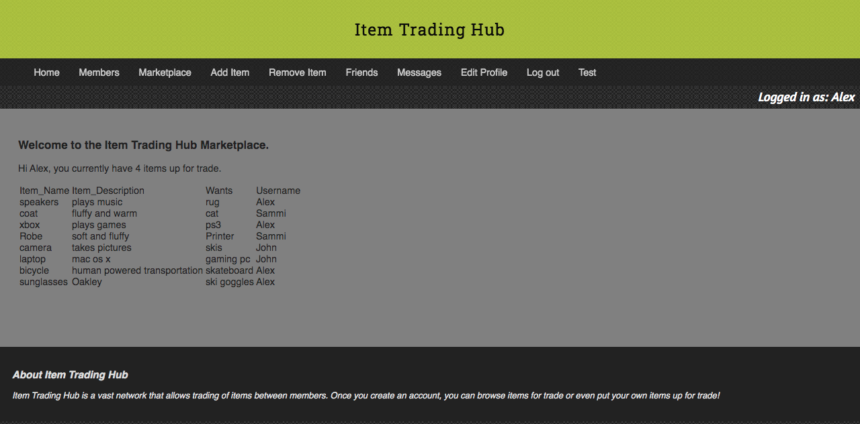
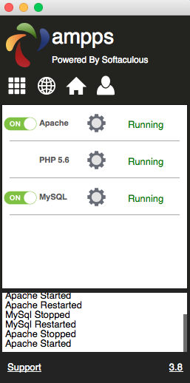

Screenshots of the AMPPS interface and Marketplace page on the Item Trading Hub website.

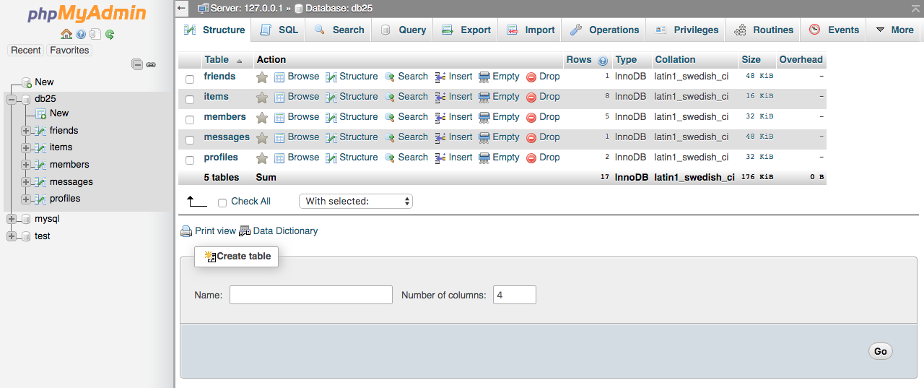

An image of what the database interface looks like – the friends, items, members, messages, and profiles tables can be seen.


The website’s database is the meat of the project. The database holds user login usernames and passwords, messages between members, friendship data, custom user profile information, and most importantly, items that users have put up for trade. By using mySQL queries to the database within the PHP files, the website can create new users, provide login/logout functionality, host user profiles, and serve the table of items up for trade.
Example SQL queries for: logging in, and showing the items that the logged in user has posted, respectively


The queries essentially ask the database to provide data stored in the database tables that is then stored in a PHP variable. The PHP variable can then be manipulated in different ways to provide different functionality.

The webpages are ‘built’ dynamically by the PHP code. The PHP essentially creates HTML code by declaring it from top to bottom of the webpage. This is then read by the web browser so the page can be displayed.
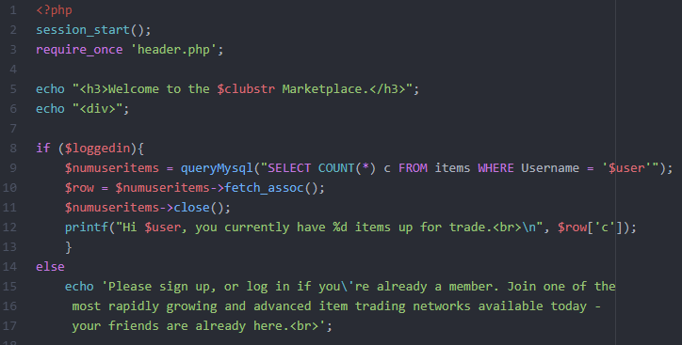

A snippet of PHP code. The HTML is built from top to bottom via PHP ‘echo’ statements, if/else statements, and declaring other PHP files to be read.
Member Contribution

Originally this project was a three-person team, but two of the members dropped the class before any work on the website had begun. At this point it was too late to shift the website groups around to get more members on the team, so this ended up being a one person project. The work that was done on the website was completed by Alex Johnston which included:

- CSS reformatting of the “lamp stack” website to better suit the needs of the project and modernize the design

- Research regarding how to properly interact with the mySQL database and add/remove items from database tables using PHP

- Coding of new PHP webpages and creation of mySQL queries to enable core website functionality

- Testing, debugging, and fixing core website features

The most difficult part of this project was figuring out how to work with the database and create functionality on the website that could interact and modify items in the database. Having never worked with any kind of database before, this was new territory and proved to be time consuming to figure out how to make it work properly.

Alongside getting the database to work, writing PHP code for the new webpages was also tricky to get right. Being quite different from HTML, it was a challenge to learn the syntax to create the webpages dynamically with PHP.

Conclusion

A lot was learned in the creation of this project, from how to link a database and website together to learning how to use entirely new coding languages. I think the implementation of the database for creating new items for trade was the right approach, as the website already used the database for storing user profiles and data. This made it relatively straightforward to implement adding a new table to the database and begin pulling and sending data to and from it. If there were to be another iteration of the website, I would like to be able to pull the item data from the table in the database and use it to populate separate webpages for each item that is up for trade. Each item would have a link to a separate webpage that would be populated with data from the items table in the database, as well as images and longer descriptions of the items for trade. I think this would give the website better functionality and make it more like Craigslist, where each item would have its own dedicated webpage that is populated with data about that item.
I also would have liked to explore other technologies like React or Node.js to build the website with, but with time and personnel constraints I didn’t feel like this would be feasible if a working prototype was the end goal. Not having any prior experience with more advanced website building techniques like using databases or PHP made the starting point more difficult. However, I did learn a lot about databases and how to interact with them without using sophisticated tools that do a lot of the heavy lifting for you.

References

Frank McCown, Stefan Brandle, Jonathan Denning, Jonathan Geisler, Roman Lysecky, Evan Olds, Alex Edgcomb, Arian Jimenez. (2018). CSCI 491: Web Development. Retrieved from https://learn.zybooks.com/

