AN INITIAL INVESTIGATION ON THE USE OF FRACTIONAL CALCULUS WITH NEURAL NETWORKS

Sam Gardner, Robbie Lamb, John Paxton
Montana State University - Bozeman
Computer Science Department
Bozeman, MT 59717 USA
gardner/lamb/paxton@cs.montana.edu

ABSTRACT
The widely used backpropagation algorithm based on stochastic gradient descent suffers from typically slow convergence to either local or global minimum error. This backpropagation algorithm bears great resemblance to a classic proportional integral derivative (PID) control system. Fractional calculus shows promise for improving stability and response in feedback control through the use of non-integer order derivatives and integrals. In this paper, the application of fractional calculus to backpropagation is explored as a means for improving speed and performance.

KEY WORDS
Neural Network, Backpropagation, Feedback Control, Fractional Calculus

1. Introduction

Backpropagation, though widely used as a training algorithm for artificial neural networks, is often criticized for its typically slow convergence to some minimum error in its search space. The algorithm works much like a classic feedback control system. In general, a controller’s job is to wrestle an often uncooperative system into doing what it is told. The system being controlled is referred to as the plant. For backpropagation, this is the neural network. Both backpropagation and generalized control systems compute the error between a target value and an actual output. The error is then used to adjust the plant’s behavior by tuning any knobs accessible to the controller, in an effort to reduce future error. For backpropagation, this means updating the weights on network connections. A good control system is able to utilize the information in the error signal to quickly reduce the error, thereby producing the target response in minimal time. In many cases, fractional calculus can be applied to improve the stability and response of such a system [1][2], through the use of non-integer order integrals and derivatives in place of the typical first order ones. In this paper, the effects of applying fractional calculus to the backpropagation algorithm are explored by running neural networks using various combinations of the modifiable parameters. Three types of neural networks are compared. The basic neural network (BNN) is trained using standard backpropagation. The PID neural network (PNN) is trained using classic integer order PID control. The fractional neural network (FNN) is trained using all the elements of PID control as well as fractional calculus. The results of training neural networks using all three methods are analyzed and future work is contemplated.

2. Background

Neural networks can theoretically be used to learn arbitrarily complex functions for classification, decision, and similar tasks. In the simplest case, a fixed topology is trained by iteratively adjusting the weights between nodes. The resulting weight values determine the performance of the network. Consequently, the training algorithm is of high importance to a neural network, particularly if some form of real-time learning is to be attempted. Our implementation makes use of the sigmoid

$$σ=\frac{1}{1+e^{−\text{net}}}$$ | (1)

as a thresholding function at the output of each node. The input to the sigmoid function, net is the sum of each upstream node i's output x_{i} multiplied by the weight w_{ji} of its connection to the node of interest j.

$$\text{net}=\sum_{i ε \text{Upstream}(j)}{x_{i}⋅w_{\text{ji}}}$$ | (2)

2.1 Backpropagation

Training a neural network with stochastic gradient-descent-based backpropagation is relatively simple [3]. The network is provided with a set of training samples along with their target outputs. One by one, each sample is fed into the inputs of the neural network. The resulting outputs are then compared to the target values and an error is calculated for each node, starting with nodes in the output layer and propagating backward toward nodes in the input layer. The error at an output node i, with respect to its target t and output o, is

$$δ_{i}=\overset{˙}{o}(t−o)$$ | (3)

The error at hidden node i, with respect to each of its downstream connections j, is

$$δ_{i}=\overset{˙}{o}⋅\sum_{j ε \text{Downstream}(i)}{w_{\text{ji}}⋅δ_{j}}$$ | (4)

Each weight w_{ji} between nodes i and j is adjusted based on a learning constant η, the calculated error δ_{j} at the target node j and the output x_{i} of the source node i.

$${Δw}_{\text{ji}}=η⋅δ_{j}⋅x_{i}$$ | (5)

One complete iteration through the set of training samples is referred to as an epoch. Experiments referenced in this paper run for a fixed number of epochs, though other termination conditions are common.

2.2 PID Control Systems

Proportional, integral, derivative (PID) control is a popular strategy for designing a simple feedback control system. Three constants are used to weight the effect of the error (the P term), the integral of the error (the I term), and the derivative of the error (the D term) in a PID controller. Often the derivative is taken on the system output, rather than on the error [4]. The PID control constants are summarized in Table 1.

Constant
Term | Weight for:
K_{p} | P | error (analogous to η)
K_{i} | I | integral of error
K_{d} | D | derivative of error

Table 1: PID Control Constant Summary

The effect of backpropagation on each weight of a neural network bears a striking resemblance to a PID control system as shown in Figure 1a. In basic backpropagation, as described here, the I and D terms are not present. However, multiplying the error by the derivative of the output has an effect similar to that of the D term. The effective control system that exists in standard backpropagation is shown in Figure 1b.

For a BNN, the learning constant η acts as the proportionality constant K_{p}, acting on the error. The derivative of the output $\overset{˙}{o}$ used in error calculation is similar to the D term element in PID control.

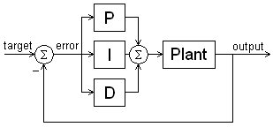 | (a)
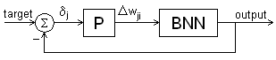 | (b)
Figure 1: (a) Typical PID and (b) Basic Backpropagation Control System Diagrams
For training the FNN, the Δw_{ji} computation was modified from that of the basic backpropagation algorithm in Equation 5.

$${Δw}_{\text{ji}}=\left(K_{p}δ_{j}+K_{i}\int{δ_{j}\text{dt}}+K_{d}\frac{d}{\text{dt}}δ_{j}\right)⋅x_{i}$$ | (6)

2.3 Fractional Calculus

Fractional calculus captures the concept of differentiation and integration to non-integer order [5][6]. In the continuous definition of derivatives and integrals, an integral is merely a derivative of negative order. A half order integral is equivalent to a negative half order derivative (q = -0.5). The formula used in our software implementation for the q^{th} order fractional derivation of function f at time t is as follows

$$D^{q}f\left(t\right)=\begin{matrix}\text{lim} \\ N→∞\end{matrix}\left\{{\left[\frac{t−a}{N}\right]}^{−q}\sum_{k=0}^{N−1}{ω_{k}}f\left(t−k\left[\frac{t−a}{N}\right]\right)\right\}$$ | (7)

In Equation 7, a is the beginning of time (the start of the history buffer), N is the number of time steps between a and t, and ω_{k} is the weight applied to f at the (t – k)^{th} time step:

$$ω_{k}=\frac{Γ\left(k−q\right)}{Γ\left(−q\right)Γ\left(k+1\right)}=ω_{k−1}⋅\frac{k−1−q}{k}$$ | (8)
$$ω_{0}=1,∀q$$ | (9)

The recurrence relation in Equation 8 can be computed using the following property of the gamma function for integral values of n.

$$Γ\left(n+1\right)=n!=nΓ\left(n\right)$$ | (10)

The algorithmic implementation stores a fixed length history for any particular derivative in a ring buffer. A list of weights for each history point is computed using Equation 8 and Equation 9. The weights are then stored in a buffer of appropriate length, for use in each derivative computation. To compute the derivative at each successive point in the input function, its value is added to the history buffer (replacing the least recent point). The entire contents of the history buffer are then multiplied by their corresponding weights and summed to produce the instantaneous derivative.

For the experiments referenced in this paper, the PID control approach was augmented with fractional calculus by setting the order of the error’s integral and derivative to λ and μ respectively. The result is a PI^{λ}D^{μ} controller [1].

3. Experiments

Customized software was written in C++ to allow for the necessary PI^{λ}D^{μ} modifications. The experiments performed, compared training sessions of the BNN to those of the PNN and the FNN. The three training algorithms are distinguished by the weight update rule used. As would be expected, the BNN uses the simple weight update rule in Equation 5. Both the PNN and FNN make use of the more complicated weight update rule in Equation 6. The FNN uses fractional integrals and derivatives computed using Equation 7, while the PNN uses the standard accumulation and difference methods to compute first order integrals and derivatives. All three utilize the target node’s instantaneous error as δ_{j} in the proportional error term, and adjust the weights after each training sample is evaluated. For the integral and derivative terms in the PNN and FNN, δ_{j} is taken to be the average error over the previous epoch.

3.1 Data Sets

Multiple data sets were initially considered. However, due to the preliminary nature of these investigations, the data set used for the experiments described is a very simple one. It consists of a single input in the range [0.05, 0.45]. The target output is twice the input, constraining output values to the range [0.1, 0.9]. This range was chosen for compatibility with the sigmoid function in Equation 1.

3.2 Experimental Methodology

The neural network topology used in all experiments consists of 3 layers, as shown in Figure 2. The input layer contains both a bias node and 1 input node. The hidden layer contains a bias node and from 1 to 5 nodes depending on the experiment. The output layer contains a single node.

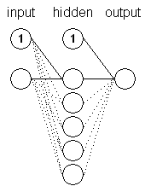 | Contents:  2 input nodes  (including one bias)  2-6 hidden nodes (including one bias)  1 output node
Figure 2: Neural Network Topology.

As is common, initial weights were set to small random values in the range [-0.5, 0.5]. The initial neural network was then saved to file and loaded for all of the experiments. Fifty random inputs were generated with their target outputs as training data, and 50 more were generated for validation data. The same random data points were then used for all experiments.

The modifications to backpropagation made for the PNN and the FNN add several tuneable parameters. In addition to η, appropriate values for K_{p}, K_{i}, K_{d}, λ, μ, and history size must all be selected. To cut down on the search space for choosing these parameters, existing rules of thumb for PID controllers were considered.

One method of selecting values for the control constants
is the Ziegler-Nichols Ultimate-Cycle Method [7]. The controller is run with K_{i} and K_{d} set to zero. K_{p} is adjusted until the output shows sustained oscillations. The ultimate gain K_{u} is set to the resulting value of K_{p} and the period of the oscillations T_{u} is measured. Suggested control constants are then

$$K_{p}=0\text{.}6K_{u}$$ | $$K_{i}=1\text{.}2\frac{K_{u}}{T_{u}}$$ | $$K_{d}=4\text{.}8\frac{K_{u}}{T_{u}}$$ | (11)

This method was attempted a few times with limited success. Measurements for the period of oscillations were inaccurate and likely contributed to the poor results. Consequently, the exploration of the domain was done by running several sweeps over combinations of the parameters. A sweep consisted of multiple training sessions, for which each parameter was stepped through a small range of values. One session was run for every combination of the values. Reviewing graphs from these sweeps provided a better feel for the system’s behavior.

3.3 Results

For all experiments, λ and μ were both set to 0.5 and history size was set equal to the experiment’s duration in epochs.

In many cases the BNN, PNN, and FNN behaved similarly. As seen in Figure 3 the performance similarities are clear, although there are subtle nuances among them. Figure 3 shows the FNN’s mean squared error (MSE) on the validation set decreasing more rapidly than the others and starting to drop off steeper toward the 6,000th epoch. This graph was chosen to show more differentiated behaviour than usual. For this experiment the following settings were used: 5 hidden nodes,
η = K_{p} = 24, K_{i} = 0.1, and K_{d} = 10.0.

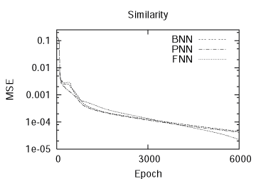
Figure 3: BNN, PNN, and FNN similarity

In the short run, the FNN often achieved a lower MSE than the BNN or the PNN. One such case is illustrated in Figure 4. The BNN and PNN behave almost identically, while the FNN reaches a lower MSE first. For this experiment the following settings were used: 5 hidden nodes, η = K_{p} = 22, K_{i} = 0, and K_{d} = 8.

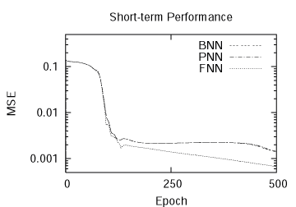
Figure 4: Short-Term Performance Comparison

As long as the PNN and FNN parameters had stable settings, all three algorithms were found to behave the same way over the long-term (30,000 epochs).

In a few experiments, the FNN stopped improving early in the run and its MSE actually began to rise and level off, as shown in Figure 5. In many of these instances, the PNN improved its error more steadily than the BNN, indicating that the divergence of the FNN is due to inappropriate parameter settings. For this experiment the following settings were used: 5 hidden nodes, η = K_{p} = 22, K_{i} = 0.5, and K_{d} = 0.2.

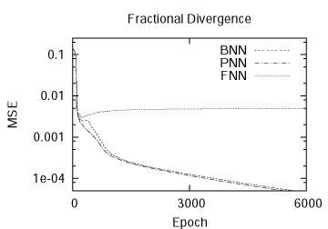
Figure 5: Divergence of FNN from BNN and PNN

In other cases, the FNN showed robustness by regaining stability where the PNN was unable to do so. Figure 6 shows both the PNN and FNN oscillating wildly early in the experiment. The PNN settles to a high constant value, while the FNN stabilizes and begins to track the BNN again. For this experiment the following settings were used: 1 hidden node, η = K_{p} = 21, K_{i} = 0.0, and K_{d} = 15.0.

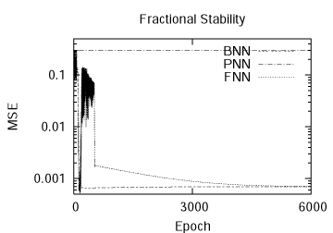
Figure 6: FNN more stable than PNN

Figure 7 shows the best runs of each algorithm encountered during testing, for comparison purposes. The PNN had the lowest MSE, followed by the FNN and then the BNN. As can be seen, the FNN and BNN tracked one another closely. For this experiment, there were 5 hidden nodes. The BNN settings were η = 22.5, the PNN settings were K_{p} = 22, K_{i} = 1.5, K_{d} = 10.0 and the FNN settings were K_{p}= 21, K_{i} = 0.0, K_{d} = 5.0.

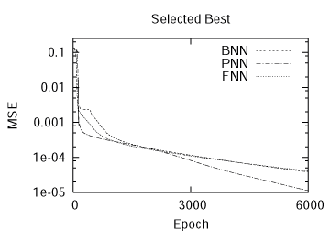
Figure 7: Individual Best Performances

4. Future Work

From a PI^{λ}D^{μ} control system standpoint, the backpropagation algorithm appears somewhat illogical. The use of both instantaneous error and average error in the weight update formula is unexpected. The control system integration, therefore, needs to be reconsidered or justified. Changes that couple the control system more directly to the network weights might also improve results.

Some of the experiments produced chaotic results. This phenomenon is widely recognized as instability in control theory - particularly in cases where the system goes into sustained oscillation and the error increases without a theoretical bound. Even so, more investigation into the temporary oscillations encountered in these experiments may prove to be instructive, and lead to improvements in the algorithm. An example of such an oscillation is shown in Figure 8. For the experiment depicted in Figure 8, there were 5 hidden nodes, η = K_{p} = 24, K_{i} = 0.5 and K_{d} = 3.0. Anytime the parameters to the training algorithm were poorly selected, considerably worse oscillation occurred. This seemed most common when K_{i} was raised too high.

Plenty of data collection and analysis remains. Comparison of computational complexity among the three algorithms has yet to be completed. For a given training instance, it is clear that the FNN requires the most amount of computation and the BNN the least. However, it is possible that one system might require fewer training epochs than another.
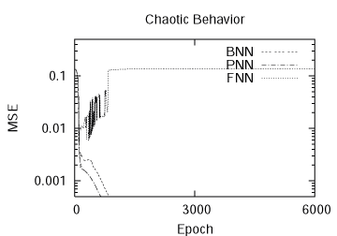
Figure 8: Chaotic Behavior of a FNN

More investigation into tuning the parameters for the FNN would be useful. Getting a better feel for the settings that work could lead to a rule of thumb, which would speed up research. For this paper, very little experimentation was done with values of λ and μ. An investigation of their effects could prove illuminating.

It is also a long-term goal of this research to identify the pros and cons of the BNN, PNN and FNN. Under what circumstances does one outperform another with respect to MSE? Under what circumstances does one outperform another with respect to computational effort? It is certain that additional data sets and network topologies will need to be explored in order to answer these questions.

5. Conclusion

The primary contribution of this paper is to show how fractional calculus and PID control is relevant to training a neural network. Three systems were coded: a BNN, a PNN and an FNN. The three systems were then compared on one specific problem across a wide variety of settings. The experiments found that (1) an FNN can reach a lower MSE in the long-term, (2) an FNN can reach a lower MSE in the short-term, (3) an FNN can be outperformed by both a BNN and a PNN and (4) a PNN had the absolute best performance.

Although it is encouraging to see that the PNN and the FNN perform well in specific cases, these experiments raise more questions than they answer. It is hoped that this paper will serve as a stepping stone for other researchers to join in the quest for a better understanding of PNNs and FNNs. The ideas from fractional calculus and PID control are exciting ones. They may extend to other aspects of neural networks, and not just to backpropagation.

Acknowledgements

Our sincere thanks goes to Gary Bohannan and Fractor Technologies, Inc. for inspiration and enlightenment.

References

[1] Y. Chen, C. Hu, B. Vinagre & C. Monje, Robust Controller Tuning Rule with Iso-damping Property, American Control Conference, Badojoz, Spain, 2004.

[2] J. Thomas, et al., Method and Device for Controlling Angular Speed of an Electromagnetic Drive Train with Little Damping, US Patent 6,856,111, 2005.

[3] T. Mitchell, Machine learning (WCB/McGraw-Hill, 1997).

[4] T. Wescott, PID without a PhD, http://www.embedded.com/2000/0010/0010feat3.htm, 2000.

[5] K. Oldham & J. Spanier, The Fractional Calculus (Academic Press, 1974).

[6] Various, Fractional Calculus, http://en.wikipedia.org/wiki/Fractional\_calculus, 2006.

[7] J. Van de Vegt, Feedback Control Systems – 3rd edition (Prentice-Hall, 1994).

